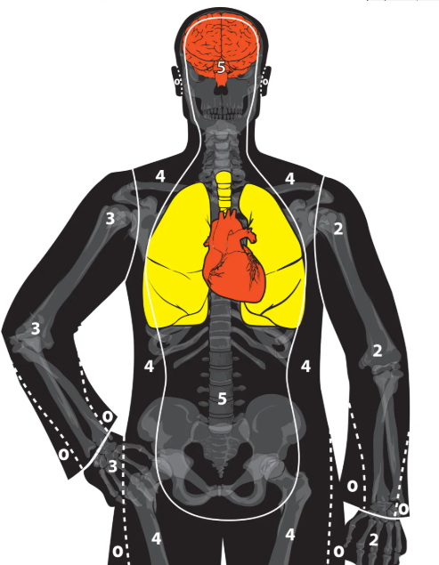
Target #1 - - - Pistol/Revolver - - - Rounds: _____ Time: _______
Distance & Par Time (Goal): Circle your choice:
3 yds (1/2 sec) / 5 yds (1 sec)
Distance : 7 yds (No Time) / 10 yds (No Time)
Name: __________________________________________ Month: __________

